#### (N.F.

###### PERFORMANCE REQUIREMENTS

As given below are the steps involved in implementing the online database.

1. E-R DIAGRAM:

The E-R Diagram constitutes a technique for representing the logical structure of a database in a pictorial manner. This analysis is then used to organize data as a relation, normalizing relation and finally obtaining a relation database.

**Entity:** Which specify distinct real-world items in an application.

**Properties/Attribute** :Which specify properties of an entity and relationships.

**Relationship:** Which connect entities and represent meaningful dependencies between them.

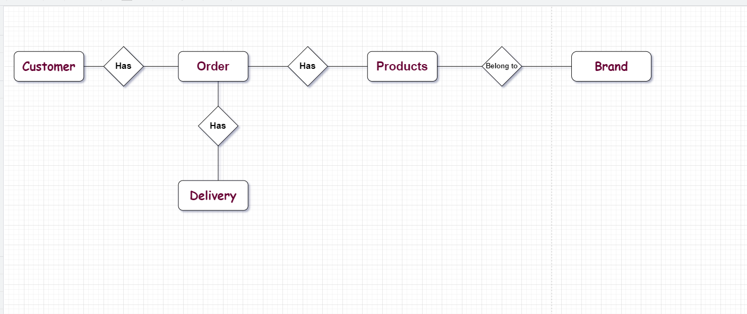

1. NORMALIZATION:

the process of structuring and handling the relationship between data to minimize redundancy in the relational table and avoid the unnecessary anomalies properties from the database like insertion, update and delete. It helps to divide large database tables into smaller tables and make a relationship between them. It can remove the redundant data and ease to add, manipulate or delete table fields.

A normalization defines rules for the relational table as to whether it satisfies the normal form. A **normal form** is a process that evaluates each relation against defined criteria and removes the

multivalued, joins, functional and trivial dependency from a relation. If any data is updated, deleted or inserted, it does not cause any problem for database tables and help to improve the relational table' integrity and efficiency.

###### SAFETY REQUIREMENTS

If there is extensive damage to a wide portion of the database due to catastrophic failure, such as a disk crash, the recovery method restores a past copy of the database that was backed up to archival storage (typically tape) and reconstructs a more current state by reapplying or redoing the operations of committed transactions from the backed up log, up to the time of failure.

###### SECURITY REQUIREMENTS

Security systems need database storage just like many other applications. However, the special requirements of the security market mean that vendors must choose their database partner carefully.

1.  
   * **AVAILABILITY:** The item should be available on the specified category when the customer reserve.
   * **CORRECTNESS:** The order should reach start from the correct destination.
   * **MAINTAINABILITY:** The system should maintain correct schedules information of the orders to meet the changing needs of customers. This is a critical attribute because software change is an inevitable requirement of a changing business environment.
   * **USABILITY:** The order schedules should satisfy a maximum number of customer’s needs.
   * **Dependability and security:** system dependability includes a range of characteristics including reliability, security and safety. So the online shopping system not cause physical or economic damage in the event of system failure. In addition to Malicious users should not be able to access or damage the system.
   * **Efficiency:** the system should not make wasteful use of system resources such as memory and processor cycles. So the system includes responsiveness, processing time, memory utilization, etc.
   * **Acceptability:** the system it must be understandable, usable and compatible with other systems that users use.

**5.5 User interface**

**Home page**



**Account:  
**

**Login:** 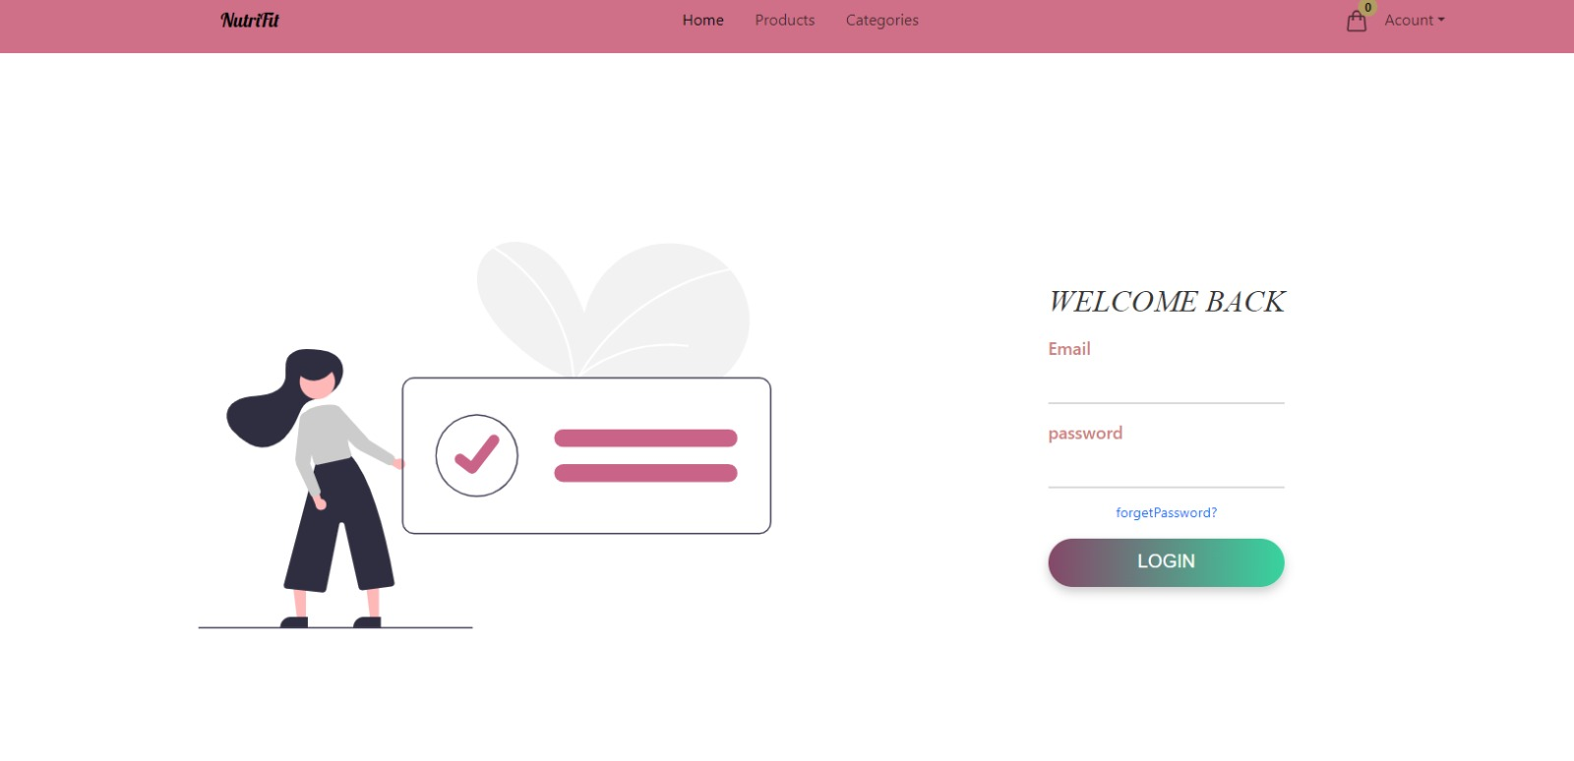

**Singup:**

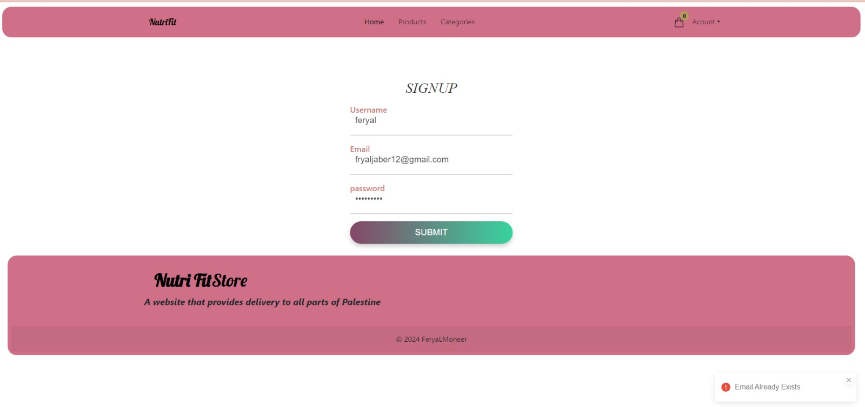

**Forget password:**

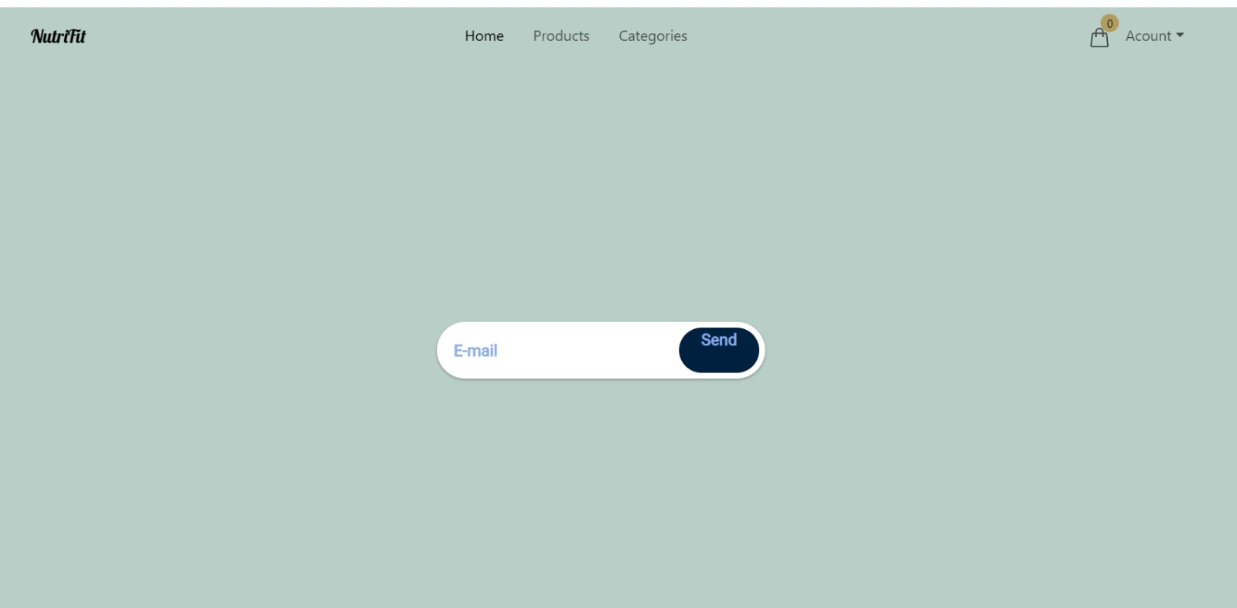

**Products:**

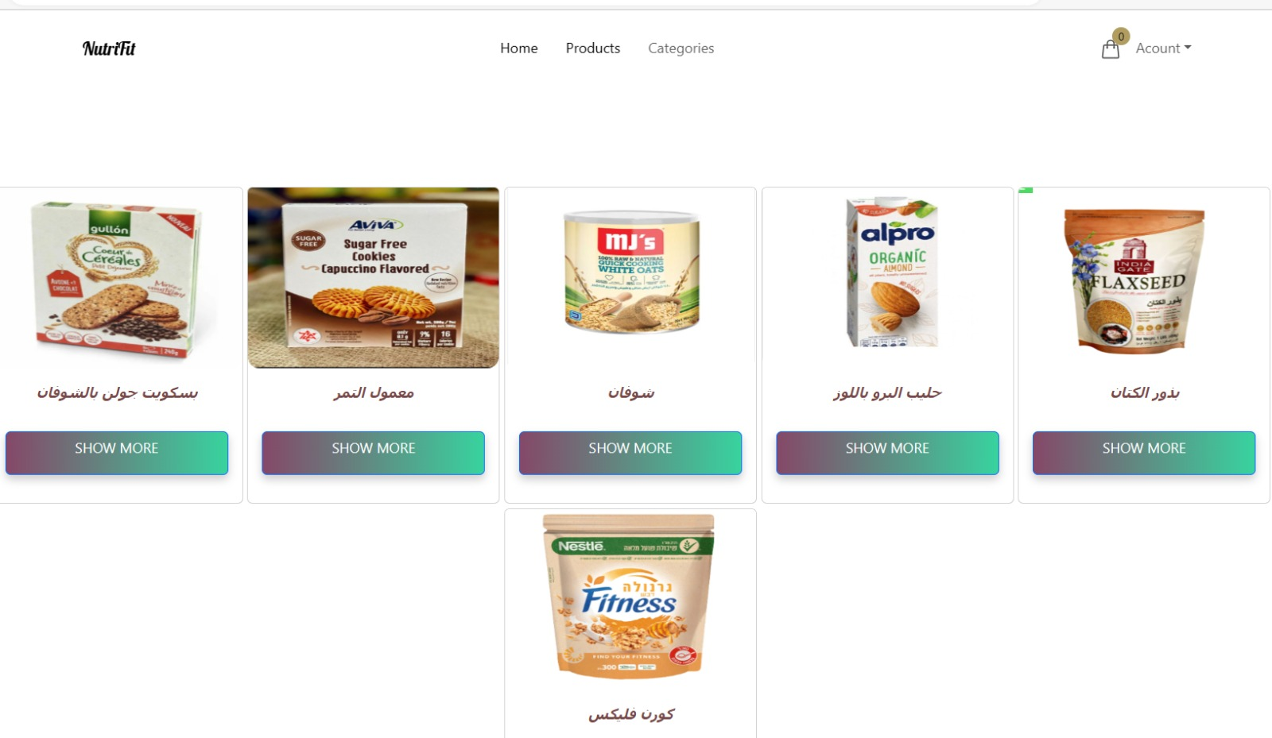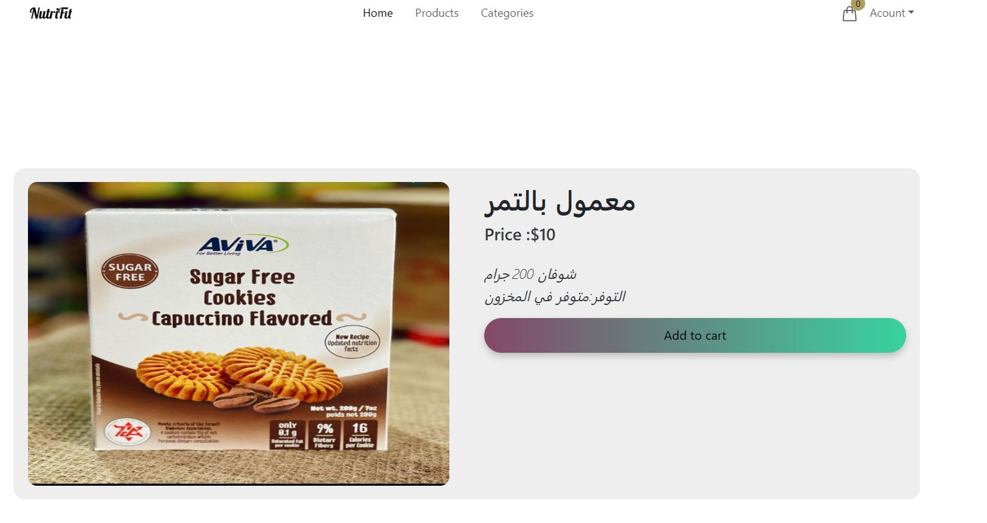

**Categories:**

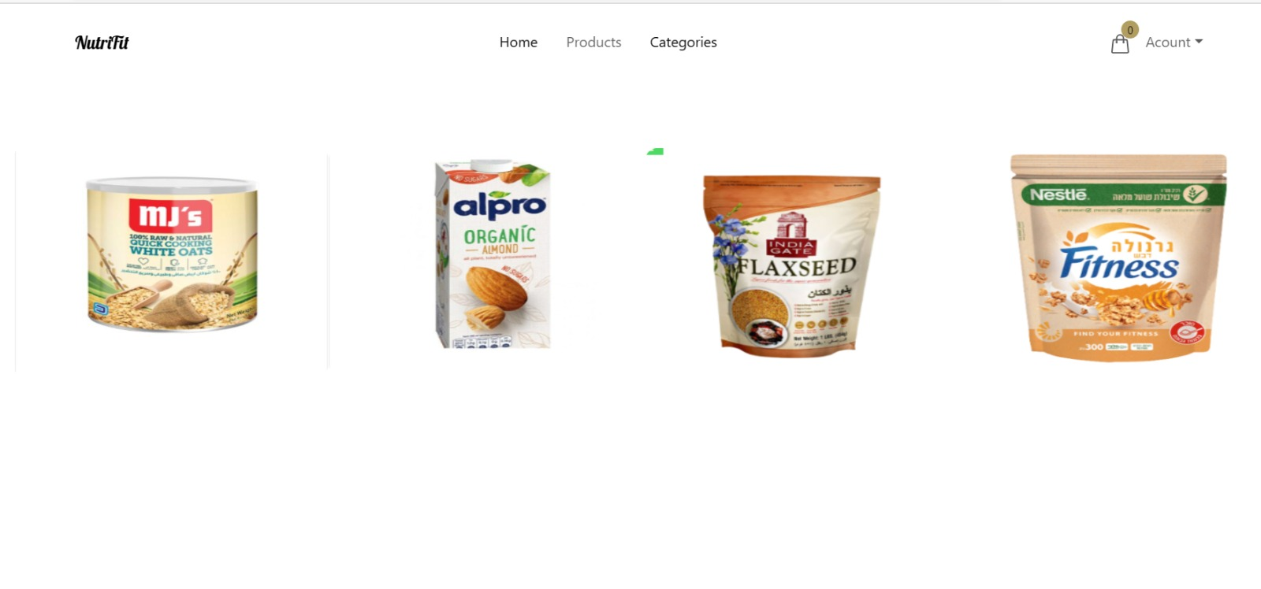

* 1. **Sequence Diagram**